How to Print to a Campus Printer from your Laptop
Start at Methodistcol.edu and then scroll down to “Web Print” in the Quick Links, or bookmark the Web Print login page here: https://papercut.methodistcol.edu/user
Log In with your username (Short login name that you use to get into CAMS or log onto campus PCs with, not your full email address) and the same password you use for everything else
Find your PIN here where it says Card/ID:
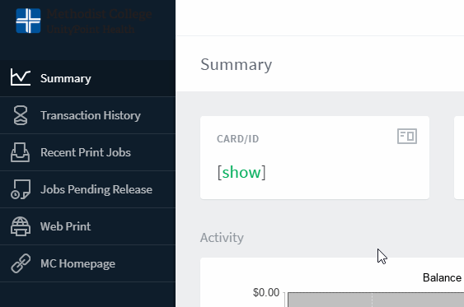

Go to “Web Print” on the left, then click “Submit a Job”
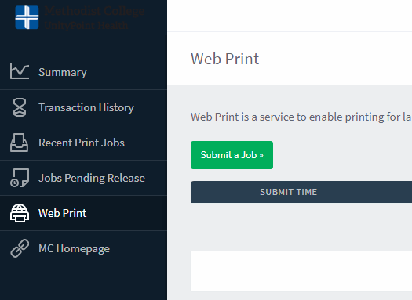

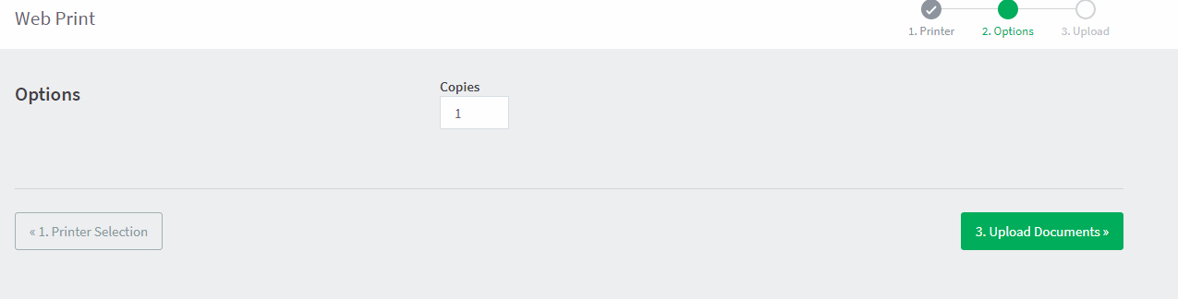

Under Printer Selection, the only option is going to be the Library Printer.
Click “Upload Documents” and find the one you want to print, do note that often if its still open when you try and print it, it will either take longer or give an error, its best to have the document closed before trying to print it.
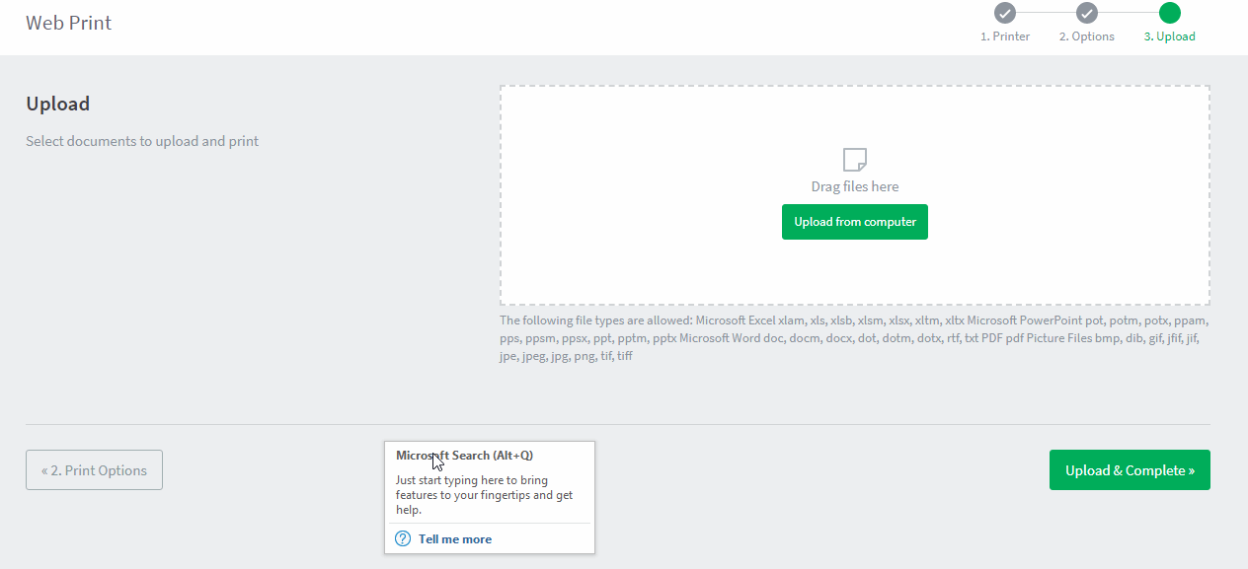
You can print multiple files at a time, but you don’t get to control much when you go to print it. It will not give you any options as far as printing double sided, only printing certain pages, portrait/landscape etc. It will only print the document the way its saved.
Click Upload & Complete when you’re done.
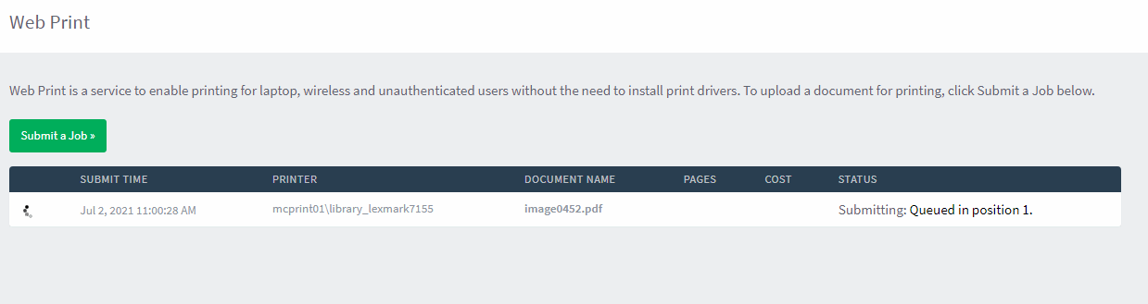
It will go through a few stages of processing before its ready since the print server has to convert the file into printable form then send it to the printer. Once it says “Held in Queue” its ready to print:
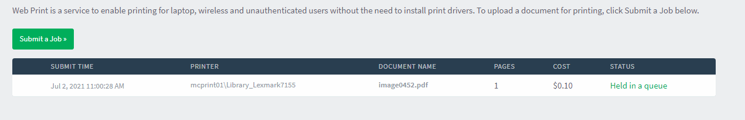

At this point you can go ahead and go to the printer, enter your PIN and tell it to print. It will hold the print job for 2-3 hours before it automatically deletes it from the queue.

